Village
Happenings

August 2022

William Shakespeare wrote that "Summer's lease hath all too short a date." Though we are in agreement with the bard, the Resident Services Department is trying hard to keep the spirit of summer alive at the Village as long as we possibly can! This month we will offer three band concerts under the tent including performances by the Satuit Concert Band, the Anthony Geraci Trio, and the Tinkertown Band. Vivacious and talented singer Laura James will return to the Village and the amazing concert pianist Fred Moyer is scheduled to perform for us again. Our traditional Summer Cocktail Party accompanied by the Island Music of the Steel Rhythm Band featuring a raw bar is an event not to be missed! An Ice Cream Sundae Bar will also be held under the Tent. We are sponsoring a Newport, Rhode Island Lighthouses Cruise and a trip to the Priscilla Beach Theater to view "Something Rotten". Beth Cameron-Kilbridge will present a lecture on E.B.White and author Michael Tougias will discuss his book "In Harm's Way". Resident Sandy Macfarlane will host a Brown Bag Lunch and Learn on “Shellfish in the Northeast”. These events and so many more will make the month of August last in our memories for the entire year!
Monday, August 1 Women’s Breakfast (See Special Dining)
Tuesday, August 2 Piloting Presentation with Brian Glennon (See Lectures and Courses)
Tuesday, August 2 Open Session for your Mobile Device (See Lectures and Courses)
Wednesday, August 3 Lunch at Mia Regazza (See Short Trips)
Thursday, August 4 Laura James in Concert (See Music)
Friday, August 5 Beth Cameron-Kilbridge Lecture (See Lectures and Courses)
Sunday, August 7 Priscilla Beach Theatre (See Featured Trips)
Monday, August 8 Open Session for your Mobile Device (See Lectures and Courses)
Tuesday, August 9 Quarterly Cocktail Party & Caribbean Dinner (See Special Dining)
Wednesday, August 10 Newport Rhode Island Lighthouse Cruise (See Featured Trips)
Thursday, August 11 Picnic Lunch at Bumpus Park (See Short Trips)
Friday, August 12 Elvis Presley “Blue Hawaii” on the Big Screen (See Just For Fun)
Saturday, August 13 The Satuit Concert Band (See Music)
Monday, August 15 Open Session for your Mobile Device (See Lectures and Courses)
Tuesday, August 16 Gary Hylander Lecture (See Lectures and Courses)
Wednesday, August 17 Erika Reitshamer Lecture (See Lectures and Courses)
Thursday, August 18 Anthony Geraci Trio (See Music)
Friday, August 19 Coffee with Luke (See Village Business)
Friday, August 19 Shopping at Marhall’s/HomeGoods (See Short Trips)
Monday, August 22 Art by the Bay (See Short Trips)
Tuesday, August 23 Jack Craig (See Music)
Wednesday, August 24 Brown Bag Lunch and Learn with Sandy Macfarlane (See Lectures)
Thursday, August 25 Ice Cream Sundae Bar (See Just For Fun)
Friday, August 26 Men’s Breakfast (See Special Dining)
Friday, August 26 Open Session for your Mobile Device (See Lectures and Courses)
Saturday, August 27 Fred Moyer in Concert (See Music)
Sunday, August 28 Tinkertown Big Band (See Music)
Tuesday, August 30 Author Michael Tougias “In Harm’s Way” (See Lectures and Courses)
Wednesday, August 31 Shopping at Trader Joe’s, (See Short Trips)
DINING
Monday – Saturday, Happy Hour, Tent
5:00 PM

Tuesdays – Saturdays, Outdoor Dining, Tent
5:30 PM - 6:30 PM
Due to the Dining Room Renovations beginning Monday, August 1st, dinner will take place under the tent. The dress code is casual. In the event there is inclement weather, dinner will be held in the Meeting Room.

SPECIAL DINING EVENTS
Monday, August 1, 9:00 AM, Women’s Breakfast, MR
Once a month the ladies of The Village get together for a special breakfast, and all are welcome! Please sign up in the Resident Services Activities Binder located in the Rita Welch Room.

Tuesday, August 9, 4:30 PM, Quarterly Cocktail Party and Raw Bar Featuring the
Steel Rhythm Band, Followed by Caribbean Themed Dinner, Tent

We will begin the evening festivities with our Quarterly Cocktail Party complete with an oyster and shrimp cocktail boat and special passed hors d'oeuvres. Sit back and listen to the music of the Steel Rhythm band (See Music) during this hour.
Dinner will follow with a Caribbean inspired dinner. Chef Greg and his staff have put together an authentic menu for this special occasion. Please look for your special reservation form in your in-house box

Friday, August 26, 9:00 AM, Men’s Breakfast, Tent
Gentlemen of The Village get together for a special breakfast, and all are welcome! Please sign up in the Resident Services Activities Binder located in the Rita Welch Room.

FITNESS
The fitness center will be hosting its sixth annual “Summer Fitness Challenge” contest during the month of August which is open to all residents. The fitness center offers a variety of 13 classes with a total of +30 classes a week. Here is how it works: For every class you attend, you will sign in with the instructor of that class. The fitness instructor will then put your name into a drawing. The person who attends that class the most will win a prize. All names will be entered in a raffle for prizes. The more classes you go to, the more likely you will win – It is that easy! The person who goes to the most classes in the month of August will win the grand prize. In honor of the contest, there will be an award luncheon in early September in the fitness center.
HEALTH AND WELLNESS
Podiatrist, Wednesday, August 29, 9:00 AM – 1:00 PM
Please call Health and Wellness to make an appointment.
Monday, August 29, 10:00 AM – 12:00 PM, Hearing Healthcare, Dux Rm
Lauren Warburton, Hearing Instrument Specialist, will be here for the hearing clinic from 10:00AM – 12:00 PM. Please call 508-250-9324 to schedule your appointment.

JUST FOR FUN
Mondays, 4:00 PM, Library Read-Aloud Hour “Jane Eyre” by Charlotte Brontë, resuming Monday, August 1
Orphaned as a child, Jane has felt an outcast her whole young life. Her courage is tested once again when she arrives at Thornfield Hall, where she has been hired by the brooding, proud Edward Rochester to care for his ward Adèle. Jane finds herself drawn to his troubled yet kind spirit. She falls in love. Hard.
But there is a terrifying secret inside the gloomy, forbidding Thornfield Hall. Is Rochester hiding from Jane? Will Jane be left heartbroken and exiled once again?
Friday, August 12, 1:30 PM, “Blue Hawaii” on the Big Screen, Meeting Room
In honor of Elvis Presley week, we are featuring “Blue Hawaii”
Presley’s film career can be viewed in two phases: pre–Blue Hawaii and post–Blue Hawaii. One of his biggest box office hits to date was a game changer that prompted manager Colonel Parker to insist that Presley give up any Oscar dreams and give his fans what they wanted, which was Elvis in an exotic location and singing enough songs to fill a best-selling soundtrack. Blue Hawaii had 14, the best of which is “Can’t Help Falling in Love.”
Thursday, August 25, 2:00 PM, Ice Cream Sundae Bar, Tent
It has been said that life is like ice cream, enjoy it before it melts. In keeping with that wise saying, the Resident Services Department is inviting all residents and staff to a summer Ice Cream Social under the tent. We will be making ice cream sundaes with your favorite ice cream flavors, toppings, and more! Come and enjoy!

LECTURES AND COURSES

Every week, Monday through Friday in the Club Room at 10:00 AM, video lectures and courses are available for your enjoyment and instruction. Each day of the week focuses on a different topic.

Monday: Wondrium: The World’s Greast Churches (NEW Beginning August 15)
Tuesday: BBC Earth: Life In The World’s Oceans (NEW Beginning August 9)
Wednesday: Wondrium: Great American Music: Broadway Musicals
Thursday: History Channel: The American Civil War
Friday: Expedition Unknown

Tuesday, August 2, 3:00 PM, Piloting Presentation with Brian Glennon, Meeting Room
Village at Duxbury volunteer, student, and pilot, Brian Glennon, is giving a presentation on what being a pilot is like in the modern world! Join him as he takes us through his pilot training and beyond!

Open Sessions for your Mobile Device with Monique
Tuesday, August 2, 1:30 PM – Lounge
Monday, August 8, 11:00 AM – Rita Welch Room
Monday, August 15, 11:00 AM – Rita Welch Room
Friday, August 26, 1:30 PM – Lounge

Friday, August 5, 2:00 PM, Beth Cameron-Kilbridge “E.B. White”, Meeting Room
Please join Beth Cameron-Kilbridge, Literary Storyteller Extraordinaire, returns to the Village at Duxbury to discuss author E.B.White. Beth's program is entitled "E.B.White: a life touched by an Angel" Ms. Cameron-Kilbridge will examine his long love affair with Katherine Angel. Both White and Angel were founding members of The New Yorker and she became the life blood of his work. This promises to be both an enlightening and romantic lecture.

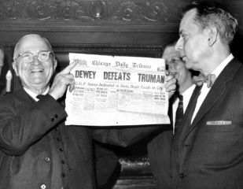
Tuesday, August 16, 1:00 PM, Dr. Gary Hylander “ Truman and the 1948 Election”, MR
Join Gary as he walks us through the 1948 Election of Harry Truman.

Wednesday, August 17, 1:00 PM, Erika Reitshamer Lecture: “Fidelio”
Ludwig van Beethoven’s only opera, subtitled
“Leonore” or “The Triumph of Married Love”

Libretto by Joseph Sonnleithner
Premiere in 1805 at the Theater an der Wien

Fidelio is an opera in two acts by Ludwig van Beethoven. It is Beethoven's only opera. The story belongs to the tradition of “rescue operas” that were in vogue around the time of the French Revolution and Napoleonic Wars. It tells how Leonore, disguised as a prison guard called "Fidelio", rescues her husband Florestan from death in a political prison. It is a musical cry for freedom and justice and has always been a politically powerful opera.

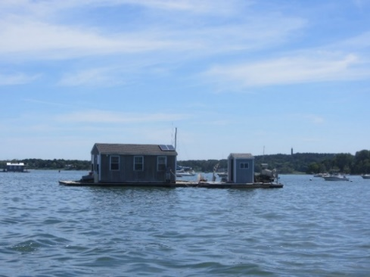
Wednesday, August 24, 12:00 PM, Brown Bag Lunch and Learn with Sandy Macfarlane “Shellfish in the Northeast: Fifty Years of our Interaction with These Succulent Shelled Creatures” Meeting Room
Rocky shores, intertidal flats, saltmarshes, bays, and coves. Clams, quahaugs, scallops, oysters, mussels. Cold water mixing with warm water creates astounding marine diversity in the New England region. Over the last 50 years, New England has been on the forefront of research and innovation. Research and application coalesced to raise awareness of the effect of land uses on the water quality and the requirements to create a booming industry, which equals an environmental and economic success story.
TED Talks, Club Room will resume on September 19th.

Tuesday, August 30, Author Michael Tougias “In Harm’s Way”

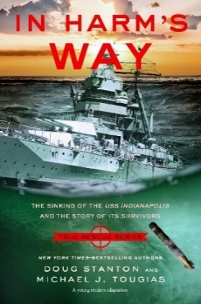
The Sinking of the USS Indianapolis and the Story of Its Survivors (True Rescue Series)

On July 30, 1945, the U.S.S. Indianapolis was torpedoed in the South Pacific by a Japanese submarine. An estimated 300 men were killed upon impact; close to 900 sailors were cast into the Pacific Ocean, where they remained undetected by the navy for nearly four days and nights. Battered by a savage sea, they struggled to stay alive, fighting off sharks, hypothermia, and hallucinations.
By the time rescue arrived, all but 316 men had died. The captain's subsequent court-martial left many questions unanswered: How did the navy fail to realize the Indianapolis was missing? And how did these 316 men manage to survive against all odds?

WELCOME TO THE VILLAGE LIBRARY!
The Library is open all day seven days a week and is staffed on Thursdays and Fridays from 1:30 to 3 PM. All new books are on the sofa table. Fiction, Nonfiction, Resident Authors, and Large Print (Fiction and Mystery) are shelved in the main room. The shelves to the left of the newspapers hold Mysteries, Biographies, Classics, Poetry, Short Stories, Audio Books, and Movies.
You may sign out books, audio books, and DVDs yourself. You may also put holds on books that are currently checked out. Instructions are posted in the Library and in the VAD Library Policies tab in the Library Catalog on Touchtown.
There are two ways to consult the computerized Library Catalogue. In your Touchtown account on your computer, click on the Library module. Or, in your computer’s browser (Safari, Firefox, Chrome, etc.), type vad.phoebe.opalsinfo.net into the address field. Feel free to post comments in OPALS (or on the comment sheet on the inside of the book’s back cover) about books you have read. Please remember to sign your name.
A new Book Selection Form has been created by Roger Tancrell and Ellen Salisbury-Ragucci and can be used in two ways. On paper: Blank forms (pink paper) are available on top of the card catalog. The completed form should be placed on the librarian's desk in the designated folder. Ellen Salisbury-Ragucci will transcribe your text into the library's computer.
On a computer: To get a blank form, go to Touchtown. Click the LIBRARY module. Click under the heading "Form for Book Suggestion” and open it. Type directly onto the form. When finished, be sure to click the green SUBMIT button at bottom of page. Completed forms will be sent to Ellen Salisbury-Ragucci. All submissions will be reviewed by the Book Selection Committee."

GOOD READS
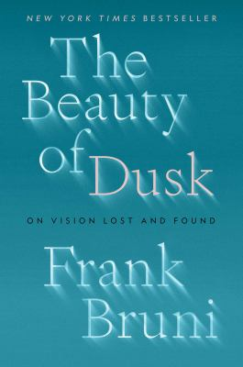
BRUNI, FRANK. THE BEAUTY OF DUSK. An exquisite writer, Bruni recounts descending into partial blindness after a small stroke and beginning a new life in semi-retirement. “An uplifting exploration of human potential … a poignant, often wise look at how nearly everything bad that happens to us can actually be good.” KIRKUS REVIEWS. “ A book about vision loss that becomes a testimony to human courage, a moving memoir that offers perspective, comfort and hope.”
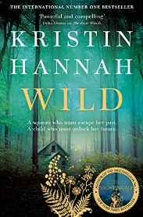
HANNAH, KRISTIN. WILD: A NOVEL. An inspiring story about the resilience of the human spirit, the triumph of hope, the promise of new beginnings. “One of Hannah’s most compelling and riveting novels.”

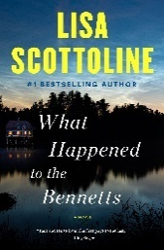
SCOTTOLINE, LISA. WHAT HAPPENED TO THE BENNETS? Explosive new complications . . . a high-octane thriller whose hero is tossed into one impossible situation after another. Best started in the morning.

MOVIES

Monday Night Movies at 7:00 PM, Club Room
This month we will feature action packed movies
Top Gun
Tom Cruise stars as a hotshot flyboy who struggles to control himself, responsibility and a steamy love affair while competing at the U.S. Navy's fighter-weapons school, better known as Top Gun. 1986 PG 1h 49m

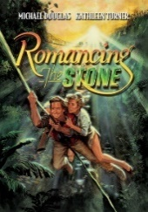
Romancing the Stone
When a reclusive romance writer -- whose humdrum life in no way resembles the exploits of her fiery fictional heroines -- learns her sister's been kidnapped, she's soon embroiled in a wild adventure involving hidden treasure and a dashing mercenary. 1984 PG 1h 46m

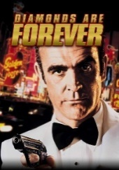
Diamonds are Forever
When he discovers that his archenemy is stockpiling the world's supply of diamonds for use in a deadly laser satellite, secret agent James Bond sets out to thwart the madman with help from beautiful smuggler Tiffany Case. 1971 PG 2h 0m

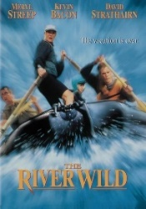
The River Wild
A turbulent vacation turns deadly when a fugitive and his crew kidnap river rafting guide Gail and her family. As they steer toward dangerous rapids, the criminals force Gail to abandon her husband Tom, who embarks on a mission to save his family. 1994 PG-13 1h 51m

The Sting
After rookie grifter Johnny Hooker tracks down veteran flim-flam man Henry Gondorff in 1930s Chicago, the duo plans to fleece a homicidal racketeer through a phony racetrack scam involving a string of double- and triple-crosses. 1973 PG 2h 9m

DOCUMENTARY SERIES
Wednesdays at 7:00 PM, Club Room
Maria by Callas
The definitive portrait of one of history's most extraordinarily talented women. Go beyond Callas, the original diva, and meet Maria, the woman who longed for a normal life. Told through private letters, unpublished memoirs, performances and TV interviews, Maria By Callas is the first film to tell the life story of the legendary Greek-American opera singer completely in her own words with never-before-seen footage. The film reveals a woman who rose from humble beginnings to become a glamorous international superstar and one of the greatest artists of all time. 2018 PG 1h 59m
Blind Spot: Hitler’s Secretary
Documentarians Andre Heller and Othmar Schmiderer turn their camera on 81-year-old Traudl Junge, who served as Adolf Hitler's secretary from 1942 to 1945, and allow her to speak about her experiences. Junge sheds light on life in the Third Reich and the days leading up to Hitler's death in the famed bunker, where Junge recorded Hitler's last will and testament. Her gripping account is nothing short of mesmerizing. 2002 PG 1h 27m

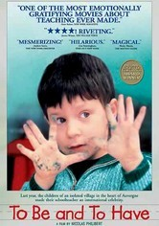
To Be and to Have
The once-acclaimed French school system is under siege, with overcrowding making it impossible for children to receive the education they deserve. But there's one place that's trying to buck the tide. This documentary by Nicolas Philibert visits a one-room schoolhouse in rural Saint-Étienne-sur-Usson, where Georges Lopez teaches his 13 students, ranging in age between 3 and 10, the old-fashioned way ... with effort, attention and encouragement. 2002 UR 1h 44m

Arna’s Children
Arna Mer Khamis was a legendary activist for the rights of the Palestinian people who founded a theatre group at a refugee camp, teaching children to express themselves through acting. Her son Juliano, a director for the group, filmed Arna working with the children over a 6-year period. Following Arna's death, he returns to the camp to find out what became of the young refugees. Best Documentary Feature winner at the 2004 Tribeca Film Festival. 2004 NR 1h 25m

American Experience: Command and Control
Command and Control presents the true story of what happens when weapons built to protect threaten to become the very source of our own destruction. Based on the bestseller by Eric Schlosser, the film tells the story of a 1980 accident at a Titan II missile complex in Damascus, Arkansas, and explores the great dilemma of our time: How do you manage weapons of mass destruction without being destroyed by them? 2016 NR 1h 32m

WEEKEND MOVIES
Saturdays at 2:00 and 8:00 PM, Club Room
& Sundays at 2:00 PM, Club Room

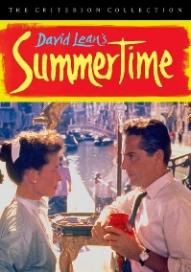
Summertime
Dreams of romance for American spinster Jane Hudson (Katharine Hepburn) become a bittersweet reality when she meets a handsome but married antiques dealer (Rossano Brazzi) while vacationing in Venice, Italy. David Lean directed this sensitive portrait of an independent woman who finds that, even in a beautiful European city, her sense of loneliness is unavoidable, and her initial disgust with the idea of an illicit love affair doesn't last. 1955 NR 1h 40m
Doc Hollywood
A Hollywood-bound plastic surgeon (Michael J. Fox) takes a detour when a fender-bender lands him in a small South Carolina town. Sentenced to community service, the big-city MD starts work at the local doctor's office ... and happens to meet the woman of his dreams (Julie Warner). Meanwhile, a pet pig keeps him company, and the quirky locals (Woody Harrelson and Bridget Fonda) keep him on his toes. 1991 PG-13 1h 44m

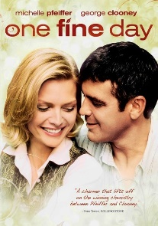
One Fine Day
When Maggie and Sammy miss their school field trip, Maggie's divorced dad and Sammy's divorced mom are forced to work together in this charming romantic comedy. At first, the grown-ups are at odds, but they warm to each other as the day progresses. 1996 PG 1h 48m

The Endless Summer
The quintessential surf film directed and narrated by Bruce Brown follows summer around the globe in 1966. Mike Hynson and Robert August ride the wild waters of Hawaii, Australia, Africa and other exotic locales in search of the perfect wave. 1966 UR 1h 32m

MUSIC
Sundays, 5:00 to 7:00 PM, Piano Bar and Buffet Dinner, MR
This way to end the weekend is a big crowd pleaser. Join your Village neighbors for drinks and buffet menu. Capture the energy and fun of a real piano bar. All are welcome.
August 7 - Steve Lanzilotta, piano
August 14 - Joe Kodzis, piano and vocals
August 21 & 28 – Paul and Mark

Thursday, August 4, 3:00 PM, Laura James in Concert, Meeting Room
Relax and enjoy the nostalgic music from the 30’s to the 80’s. Coming from a long line of musicians, Laura will perform songs from their favorite artists such as The Supremes, The Drifters, Etta James, Nat King Cole, Lou Rawls, and Billie Holiday just to name a few. Laura got her big break after performing “Unforgettable” when a member of Herb Reed’s Road Crew asked if she would like to tour with The Platters and The Drifters. They toured around the world during the 90’s.

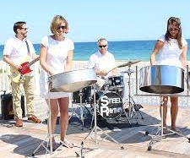
Tuesday, August 9, 4:30 PM, Summer Cocktail Party and Caribbean Themed Dinner featuring “Steel Rhythm Band” in Concert, Tent
Put on your favorite island wear and join us for an Early Happy Hour with the Steel Rhythm Band. With this energetic, enthusiastic, entertaining performance, the band has an authentic sound of modern hits while playing a wide variety of music. The band members have performed with legends such as Tony Bennet, Hugh Jackman, Andy Williams, Bobby McFerrin and Quincy Jones to name a few! Hope to see you on the dance floor!!

Saturday, August 13, 2:00 PM, Satuit Concert Band, Tent
Based in Scituate, MA, the Satuit Band has been welcoming South Shore musicians since 1933. The band is comprised of local musicians from young teens to early eighties, high school students to seasoned professionals, and every level in between.

Thursday, August 18, 3:00 PM, Anthony Geraci Trio, Meeting Room
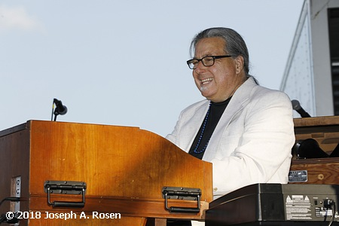
Anthony R. Geraci is an American blues and jazz pianist, organist, singer and composer. Geraci has played on stage with Muddy Waters, B.B. King, Otis Rush, Chuck Berry, Big Mama Thornton, Big Joe Turner, and Jimmy Rogers, and has recorded work with Big Walter Horton, Ronnie Earl, Big Jack Johnson, Zora Young, Sugaray Rayford, Debbie Davies, and Kenny Neal among others. Anthony’s work has been nominated for a Grammy Award and he has had numerous Blues Music Award nominations. In addition to his work with others, Geraci has released eight albums in his own name. Today, Anthony brings his musicians for an upbeat, energetic concert!

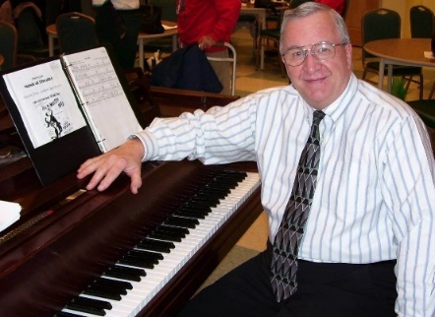
Tuesday, August 23, 2:00 PM, Jack Craig Presents “Sing! The Greatest Songs”
Sing! The Greatest Songs are programs that contain most of the favorite songs of the 20th century. Each program contains around thirty songs to sing, and Jack provides anecdotal information that recalls the best years of American song-writing. All of the songs in this program were written from 1963 – 1965 !

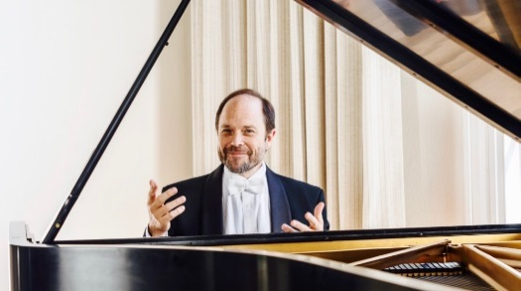
Saturday, August 27, 3:00 PM, Fred Moyer in Concert, Meeting Room
For more than 25 years as a full-time concert pianist, Frederick Moyer has carved out a career that has taken him to 41 countries and to venues such as Suntory Hall in Tokyo, the Sydney Opera House, Windsor Castle, and the Kennedy Center. He has performed as a soloist with many of the world’s great orchestras, including the Boston, Cleveland, Philadelphia, and London Symphonies. We welcome him once again to the Village stage.

Sunday, August 28, 3:00 PM, Tinkertown Big Band, Tent
After playing with the John Salerno Band on Cape Cod, Dan Kostreva, bassist, wanted to form a jazz band in Duxbury, and he finished off the loft in his barn so that there was a place for a group of like-minded musicians to rehearse. The vision became reality when Dan met up with Marty Hartford, who had a band of his own in the 80’s and still had all the music from that endeavor. Marty and Dan both had several friends who were eager to play big band arrangements, and very quickly they all were assembled for their first get-together in March of 2012. The group is quite diverse and includes seventeen men and women of all ages, all having in common the thirst for playing jazz classics by Duke Ellington, Count Basie, Glenn Miller, and many others from the big band swing era.

SPirituality
Ecumenical Service with Pastor Seth
Thursdays, 9:30 AM and 11:00 AM, Duxbury Room

Catholic Communion Service
Sundays at 10:30 AM, Duxbury Room
Sunday Scripture reading followed by distribution of Holy Communion
All are welcome.

VILLAGE BUSINESS
PLEASE NOTE:
The Residents Association Meeting will resume on September 6th.

Friday, August 19, 10:00 AM, Coffee with Luke, Meeting Room
Gather with your neighbors for beverages and pastry. Executive Director Luke Kramer gives an update on how things are going at The Village from a business perspective. He also talks about what’s coming up and answers questions from residents.
A NOTE FROM THE SUSTAINABLE VILLAGE COMMITTEE
Your sustainability group has met to increase our collective awareness about how to save energy and decrease our carbon footprint here at the VAD. Here are a few easy suggestions you can do:
1. Close your windows while your AC is on.
2. Turn off lights when you leave a room.
3. Have dimmer switches installed for lights that seem too bright.
4. VAD success! Individual water bottles have been discontinued, they were in use during the pandemic for good reason, but now the least expensive and most environmentally friendly water is from your sink into your own bottle. If you do need to buy water, look into water boxes instead of single use bottles.
5. Turn in your soft plastics to Target, Walmart or Lowes. Many places have banned plastic bags like Kohl's stores and the City of Waltham. Keeping plastic out of our landfills and water helps our environment. It's up to us to try to recycle as much as possible. Contact Abbie at 413-270-3683 if you have soft plastics you want to recycle and cannot get out to return them. Or find a friend who's going out to take them for you.
Thank you for your help and participation in making the VAD as environmentally helpful as possible!
Abbie Smith 503
VISUAL ARTS

Thursdays, 9:30 AM in the Art Studio

Professional artist and Duxbury Art Association instructor Mary LoPiccolo guides you to completion of a small watercolor painting while teaching various techniques.

Please sign up on the August Reservation Form. $20.00 for art materials will be charged to your VAD account.

WEEKLY HAPPENINGS
MONDAYS
Men’s Chorus Practice, 9:00 AM, Lounge

Lecture Series, 10:00 AM, Club Room
Please refer to your weekly calendar to find out the lecture series.

Canasta, 1:00 PM, Dining Room

Read-Aloud, 4:00 PM, Library
This activity, led by residents Marguerite Lentz and Chris McShane, continues a time-honored Village tradition.
TUESDAYS
Lecture Series, 10:00 AM, Club Room
Please refer to your weekly calendar to find out the lecture series.
Bridge Club Members Meeting, 1:00 PM, Art Studio
No sign-up needed; all registered club members are welcome. Come and have fun!
WEDNESDAYS
Lecture Series, 10:00 AM, Club Room
Please refer to your weekly calendar to find out the lecture series.

Bocce, 11:00 AM, Bocce Court
Join us on our new Bocce Court! All are welcome.

Writing Creative Non-fiction, 11:00 AM, Club Room
Work on your nonfiction writing skills in the company of others who enjoy doing the same.

Poker, 12:30 PM, Rita Welch Room
Hold onto your wallet! This is a friendly game, but these Villagers do play for cash. Feel free to stop in. This is a very hospitable group and they’ll find you a seat. Beginners are welcome.

Knitting Circle, 1:00 PM, Club Room
This convivial group of knitters gathers weekly to share patterns and work on their latest personal knitted creations. All are welcome.

Mah Jongg, 2:00 PM, Fitness Juice Bar
All are welcome to play the American version of Mah Jongg!

The Benzaquin Hour, 4:00 PM, Meeting Room
An invention of former Village resident and famous New England broadcaster and writer, Paul Benzaquin, the Benzaquin Hour is the Village’s weekly discussion group. Generally speaking, a resident facilitator will choose topics to discuss, which typically relate to the news of the day. No topic is off the table and this is a forum in which people can feel free to express their point of view - whether that is liberal, conservative, or anything in between. For more information, please talk to Grace Benzaquin.

THURSDAYS
Lecture Series, 10:00 AM, Club Room
Please refer to your weekly calendar to find out the lecture series.

Mindfulness Meditation, 12:30 PM, Duxbury Room
This class is about quieting the mind, focusing on the present moment, and accepting thoughts, emotions, and sensations that come and go, without judging or dwelling on them. This practice, over time, can make life more relaxing, joyful, and satisfying. Try it! All are welcome.
Poker, 12:30 PM, Rita Welch Room
Hold onto your wallet! This is a friendly game, but these Villagers do play for cash. Feel free to stop in. This is a very hospitable group and they’ll find you a seat. Beginners are welcome.
Darts, 4:00 PM, Art Studio
Enjoy an original board and traditional darts. All are welcome to join in the fun.

FRIDAYS
Lecture Series, 10:00 AM, Club Room
Please refer to your weekly calendar to find out the lecture series.

Corn Hole, 1:00 PM, Gazebo Lawn
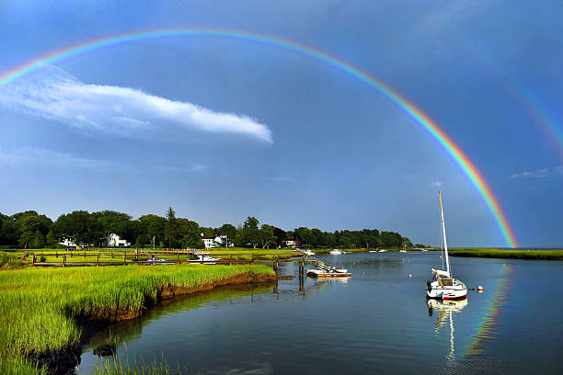
Enjoy the outdoors with this popular bean toss game. Easy for all levels!

SATURDAYS
Badminton, 2:00 PM, Fitness Center

Weekend Movie, 2:00 and 8:00 PM, Club Room
SUNDAYS
Weekend Movie 2:00 PM, Club Room
Piano Bar 5:00 PM

FEATURED TRIPS
Please sign up on the August Reservation Form
Priscilla Beach Theatre  Sunday, August 7  Departs 1:15 PM  (unescorted) | Priscilla Beach Theatre Presents “Something Rotten”  Two brothers set out to write the world’s first musical in this hilarious mash-up of sixteenth-century Shakespeare and twenty-first-century Broadway. $42.00.
Newport Rhode Island Lighthouse Cruise  Wednesday, August 10  Departs 8:00 AM  (escorted) | Newport Rhode Island Lighthouse Cruise and Lunch at Quonset “O” Club  Take a narrated cruise past 10 Rhode Island Lighthouses in Narragansett Bay along with a complete Newport Harbor Tour. This 30-mile cruise also takes you under the breathtaking Jamestown & Newport Bridges and past 10 beautiful islands, mansions, historic Fort Adams. $99.00 includes transportation, lunch, and cruise.

SHORT TRIPS

Limited to 11 residents: sign up in the Resident Services Activities Binder in the RWR

Lunch at Mia Regazza  Wednesday, August 3  Departs 11:00 AM  (escorted) | Lunch at Mia Regazza  Mia Regazza is a very popular Italian restaurant located in Marshfield. Their menu includes pasta, pizza, and fresh seafood. Lunch will be charged separately to your VAD account.
Picnic Lunch at Bumpus Park, Duxbury  Thursday, August 11  Departs 11:30 AM  (escorted) | Picnic Lunch at Bumpus Park, Duxbury  Grab a lunch from the café or bring your own and hop on our Village bus that will take us to the water’s edge. Bumpus Park is a beautiful piece of land located on King Caesar Road directly across from the King Caesar House. It overlooks Duxbury Bay where we will enjoy taking in the view and watching the boats in the harbor. Chairs and dessert will be provided.
Shopping at Marshalls & Home Goods  Friday, August 19  Departs 10:00 AM  (escorted) | Shopping at Marshalls & Home Goods, Marshfield  Get a jump start on your fall shopping. Marshalls and Home Goods offers brand-name clothing, accessories, shoes & housewares at discounted prices. Return to the Village around noon.
Art By the Bay Exhibit  Monday, August 22  Departs 2:00 PM  (escorted) | Art by the Bay Member Show, Duxbury  Enjoy the works of art from the 105th Annual Art by the Bay Member Show. The exhibit is displayed at The Ellison Center for the Arts. No charge.
Trader Joe’s, Hanover  Wednesday, August 31  Departs 10:00 AM  (escorted) | Shopping at Trader Joe’s, Hanover  Our monthly shopping trip to Trader Joe’s continues!  Step inside and you'll find unconventional and interesting products in the Trader Joe's label like Mandarin Orange Chicken and Cold Brew Coffee Concentrate, as well as everyday basics like milk, eggs, and fresh produce. They are a good source for great cheese and offer a vibrant selection of fresh flowers.

